**Farmers Insurance Analysis**

**Submitted by:** Aman & Shreevalli J

**Problem Statement:**

The PMFBY scheme provides farmers with financial security. We will analyse its effectiveness using structured data analysis. We will use SQL queries to extract key insights on premiums, claims, and farmer demographics. The challenge is to process multi-year data efficiently, identify trends, and generate reports that help stakeholders assess the scheme’s impact.

**Tasks:**

You need to perform the following steps for successfully completing this assignment:

1. Data Loading
2. Filtering Data (WHERE)
3. Apply Aggregation (GROUP BY)
4. Sorting Data (ORDER BY)
5. String Functions
6. Joins
7. Subqueries
8. Advanced SQL Functions (Window Functions)
9. Data Integrity (Constraints, Foreign Keys)

**Dataset:**  
The dataset used in this analysis is sourced from the National Data and Analytics Platform (NDAP), which hosts a wide range of government data. Specifically, the data pertains to the Pradhan Mantri Fasal Bima Yojana (PMFBY), a crop insurance scheme. It includes details such as the number of insurance units, premiums paid by farmers, contributions from state and central governments, sum insured, as well as demographic attributes like the gender and category of the farmers. The PMFBY scheme is designed to offer financial protection to farmers against crop losses resulting from natural disasters, pest attacks, or diseases.

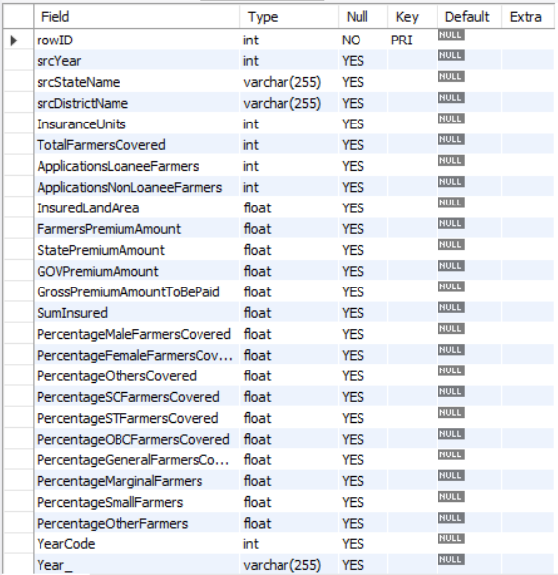

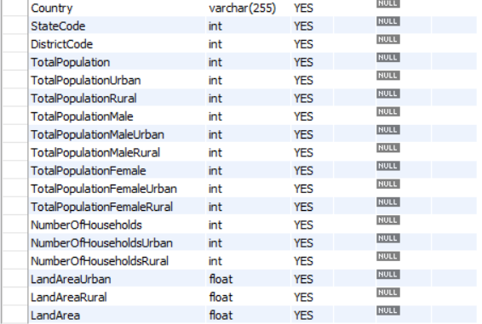

**Performance Analysis / Insights / Results:**

The analysis includes data from **27 Indian states** participating in the PMFBY scheme.

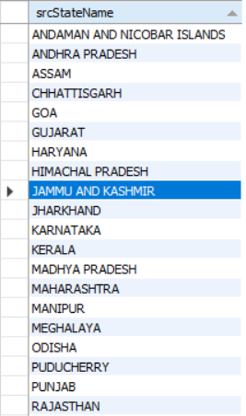

* **Madhya Pradesh** has the highest number of farmers covered, **followed by Maharashtra.**
* Punjab shows the lowest farmer coverage among all states.

* In Himachal Pradesh, **Kangra** district had a rural population of over 1 million consistently from 2018 to 2021.

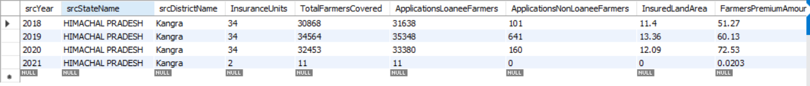

* **Ujjain district (Madhya Pradesh)** recorded the **highest total premium amount** (~3273.09), while **Hugli (West Bengal)** ranked second (~2777.03).
* In **Karnataka**, most districts report **zero farmer premium contributions**, except for **Davangere, Kolar, Mandya, and Hassan**, where premiums were slightly above zero.
* In **2018**, **16 states** had insured land areas exceeding 5 hectares.

* The **highest average insured land area** was recorded in **2020**, while **2018** showed the **lowest**.

* **Bid district (Maharashtra)** had the **highest number of farmers covered** (1,430,532) where insurance units were greater than 0.
* **Latur district (Maharashtra) ranked second with 1,184,066 farmers covered.**

* **Kodagu and Dakshina Kannada (Karnataka)** had **zero farmers covered**, despite having non-zero insurance units. In these two districts, farmer coverage is nearly negligible, even though insurance units are greater than zero.



* **Thane district (Maharashtra)** had the **highest total population** in 2020, followed by **Jaipur (Rajasthan)**.

* Grouped data by state and district shows **Karnataka and Uttar Pradesh** reporting the **lowest farmer premium amounts** (as low as 0.0002 and 0.0003). Coverage Ratio is nothing but how well Total population is covered for that particular state with respect to farmers in that state.
* The **coverage ratio** (farmers covered vs total population) was **highest in Chhattisgarh** for 2020.
* **Tripura** ranked **2nd and 3rd** in coverage ratio for the years **2020 and 2021** respectively.

* There are **60 districts** whose names begin with the letter **'B'** and **193 districts** that end with **'pur'** across India.
* **Bid (Maharashtra)** had the **highest Farmers’ Premium Amount**, exceeding **₹20 crores**, and also the **highest Sum Insured**.

* Maharashtra has the highest SumInsured amount with the highest FarmersPremiumAmount.

**Conclusion:**

* Punjab recorded the lowest number of farmers enrolled under PMFBY, indicating either low awareness or limited reliance on agriculture in the region.
* Maharashtra's Bid district had the highest number of farmers covered, showing strong engagement with the scheme in that area.
* Higher premium amounts in some districts may suggest frequent crop failures, possibly due to local climate challenges or natural disasters.
* Certain high-risk districts showed little to no insurance uptake, highlighting the need for better awareness and outreach among farmers.
* From 2018 to 2020, there was a steady increase in average insured land area, reflecting improved understanding and adoption of the scheme.
* Districts like Kodagu and Dakshina Kannada had minimal or no farmer coverage, which may be due to limited farming activity.
* There is a clear opportunity to expand the scheme in underrepresented areas through farmer education and a simplified enrolment process.
* Increasing insurance coverage in densely populated states is essential to support food production and protect farmers from financial losses.